**BILLING SYSTEM FOR GERNEAL STORE**

**ABSTRACT:**

The Comprehensive Billing System for General Stores is a robust and efficient solution designed to streamline and automate the billing processes in a general store setting. This system is built on the foundation of a well-structured SQL (Structured Query Language) database, ensuring data integrity, reliability, and ease of management.

**AIM OF PROJECT:**

The aim of the Billing System for General Store in SQL project is to create an efficient and reliable software solution that automates the billing processes in a general store environment.

**INTRODUCTION:**

The Billing System for General Store in SQL is a comprehensive software solution designed to address the intricate needs of billing and inventory management in a general store setting. As technology continues to revolutionize the retail landscape, the demand for efficient and automated systems becomes increasingly crucial. This project introduces a robust SQL-based billing system tailored to enhance operational efficiency, accuracy, and decision-making within a general store environment.

|  |
| --- |
| **BillDetails** |
| BillID (PK) |
| Cus_ID (FK) |
| Prod_ID (FK) |
| Prod_Name |
| Prod_Price |
| Prod_Quantity |
| Total_Price |
| Prod_Price |
| Date_of_Purchase |
| Payment |

|  |
| --- |
| **CustomerDetails** |
| Cus_ID (PK) |
| Cus_Name |
| Cus_Address |
| Cus_Mobile |

|  |
| --- |
| **ProductDetails** |
| Prod_ID (PK) |
| Prod_Name |
| Prod_Price |

**STRUCTURE OF TABLE**

BillDetails

DESC BillDetails;

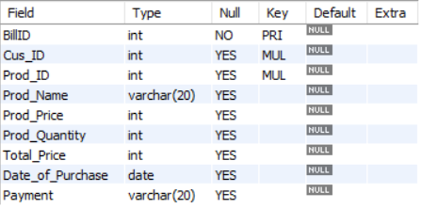

CustomerDetails

DESC CustomerDetails;

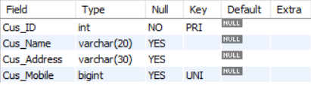

ProductDetails

DESC ProductDetails;

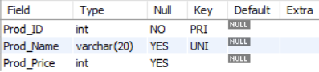

**CONTENTS OF TABLES**

BillDetails

SELECT * from BillDetails;

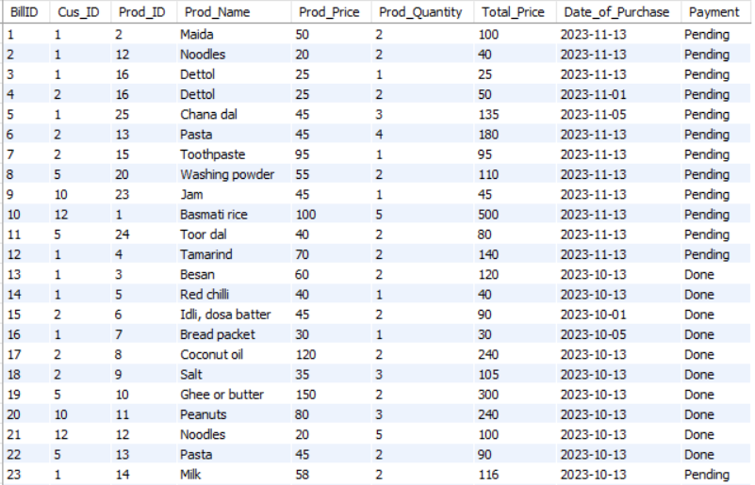

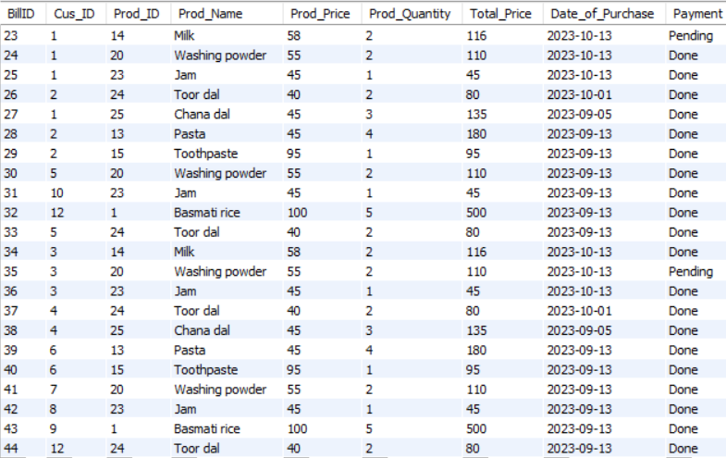

CustomerDetails

SELECT * from CustomerDetails;

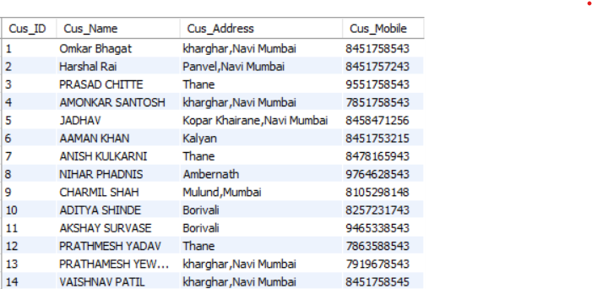

ProductDetails

SELECT * from ProductDetails;

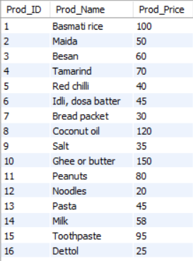

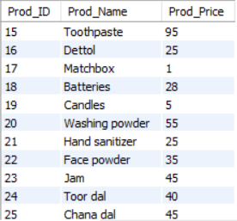

**VIEWS**

1.Create a table for the BillDetails and CustomerDetails associated with accview.

**QUERY:**

create view accview as select

BillDetails.BillID,CustomerDetails.Cus_Name, BillDetails.Total_price,

BillDetails.Payment from BillDetails,CustomerDetails where

BillDetails.Prod_Name in ('Maida','Basmati rice') and CustomerDetails.Cus_Name in ('Omkar Bhagat','PRATHMESH YADAV');

select * from accview;

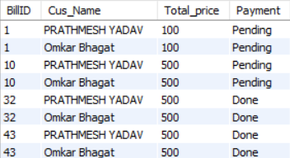

2.Create a table for the CustomerDetails and ProductDetails associated with kssview.

**QUERY:**

create view kssview as select

CustomerDetails.Cus_ID,CustomerDetails.Cus_Name,CustomerDetails.Cus_Mobile,ProductDetails.Prod_ID,ProductDetails.Prod_Name,ProductDetails.Prod_Price from CustomerDetails, ProductDetails where CustomerDetails.Cus_ID in(5,6) and ProductDetails.Prod_ID in(12,20);

select * from kssview;

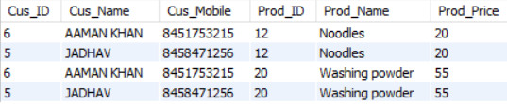

3.Show the CustomerDetails and BillDetails associated with golview.

**QUERY:**

create view golview as select

CustomerDetails.Cus_ID,CustomerDetails.Cus_Name,BillDetails.Prod_Quantity from CustomerDetails,BillDetails

where CustomerDetails.Cus_ID in (3,4) and BillDetails.BillID in (3,4);

select * from golview;

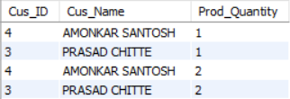

4. Update the detail of view.

**QUERY:**

update golview set Prod_Quantity=5 where Cus_ID=3;

select * from golview;

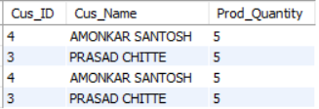

**Joins**

1.Left join:

**QUERY:**

select c.Cus_ID,c.Cus_Name,c.Cus_Address,

p.Prod_Name,p.Prod_Price from CustomerDetails c left join ProductDetails p on c.Cus_ID=p.Prod_ID;

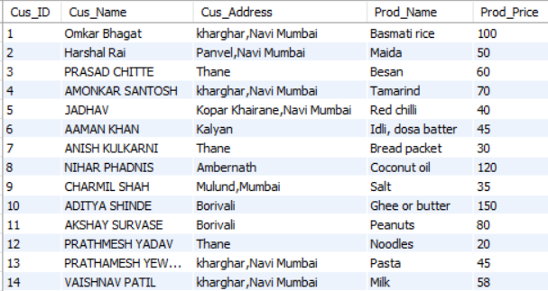

2.Right Join:

**QUERY:**

select c.Cus_ID,c.Cus_Name,c.Cus_Address,

p.Prod_Name,p.Prod_Price from CustomerDetails c right join ProductDetails p on c.Cus_ID=p.Prod_ID;

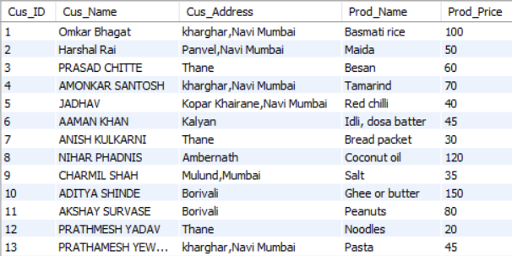

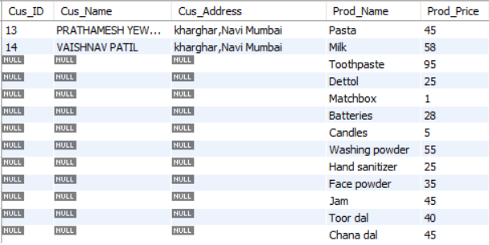

3.Cross join:

**QUERY:**

select c.Cus_ID,c.Cus_Name,c.Cus_Address,

p.Prod_Name,p.Prod_Price from CustomerDetails c cross join ProductDetails p on c.Cus_ID=p.Prod_ID;

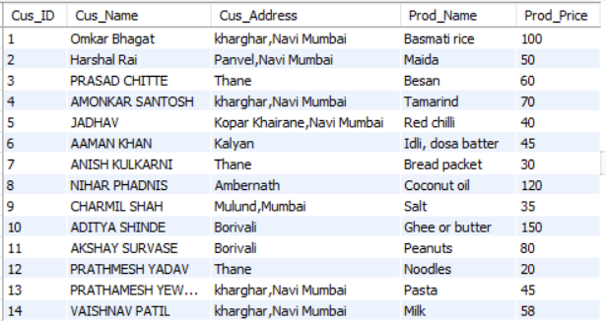

4.Inner join:

**QUERY:**

select c.Cus_ID,c.Cus_Name,c.Cus_Address,

p.Prod_Name,p.Prod_Price from CustomerDetails c inner join ProductDetails p on c.Cus_ID=p.Prod_ID;

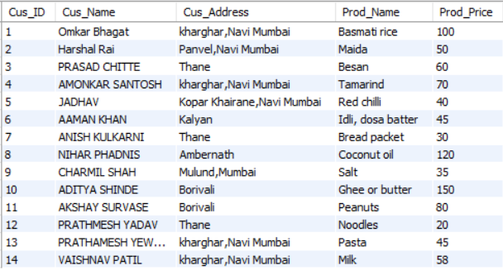

**SUBQUERIES**

**QUERY:**

select * from ProductDetails where Prod_ID in (select Cus_ID from

CustomerDetails where Cus_Name ="CHARMIL SHAH") having Prod_Price>20;



**QUERY:**

select * from BillDetails where BillID in (select Prod_ID from

ProductDetails where Prod_Price>50);

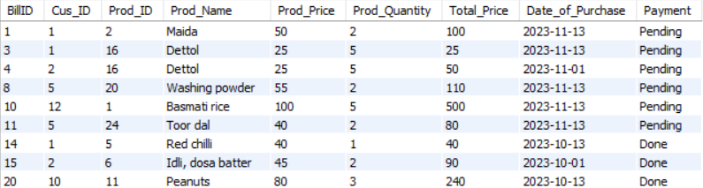

**QUERY:**

select * from BillDetails where BillID in (select Prod_ID from

ProductDetails where Prod_Name="Ghee or butter") having Total_Price>200;



**BUILT -IN FUNCTIONS**

**1.MATH**

**QUERY:**

select round (78.48);



**QUERY:**

select sqrt (64);



**2.STRING**

**QUERY:**

select upper(Cus_Name),lower(Cus_Address), length(Cus_Mobile) from CustomerDetails;

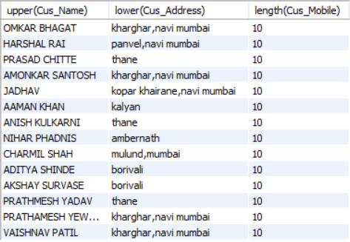

**3.DATETIME**

**QUERY:**

select date_format('2023-07-16','%y');



**QUERY:**

select sysdate();



**4.AGGREGATE**

**QUERY:**

select count(Total_Price) from BillDetails where Cus_ID=2 and Date_of_Purchase>'2023-10-31' and Payment="Pending";



**QUERY:**

select sum(Total_Price) from BillDetails where Cus_ID=1 and Date_of_Purchase>'2023-10-31' and Payment="Pending";



**THANKYOU**